Open your web browser and go to employee.nola.gov/home/
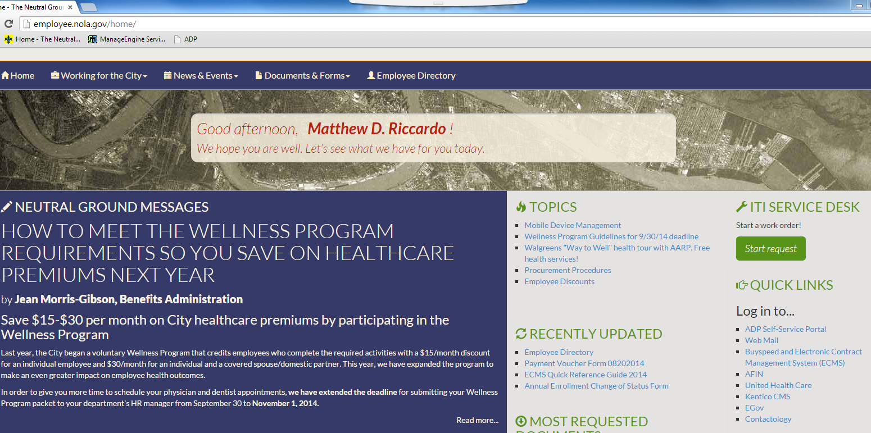

Select Mobile Device Management under the Topics Heading

Select REGISTER for Mobile Device Management (MDM) - #2
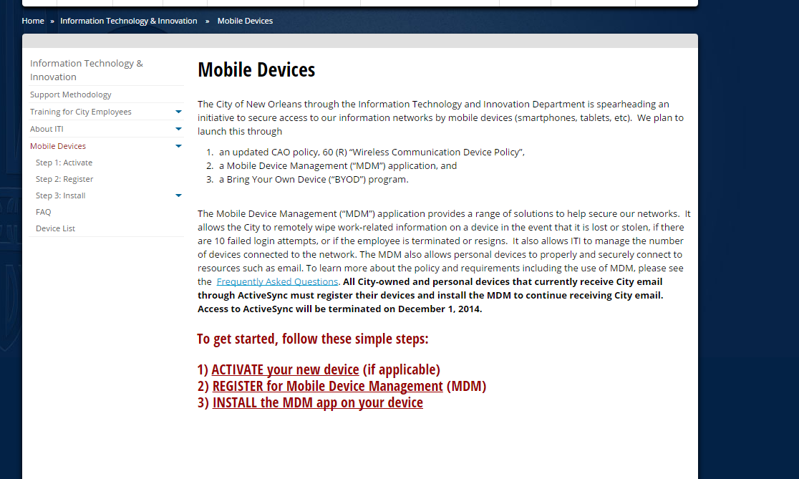

Fill in the required information and click OK
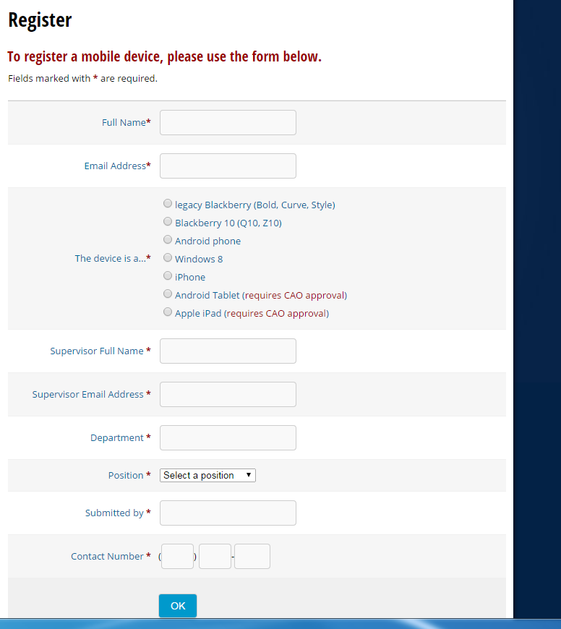

Click on Step 3: INSTALL link
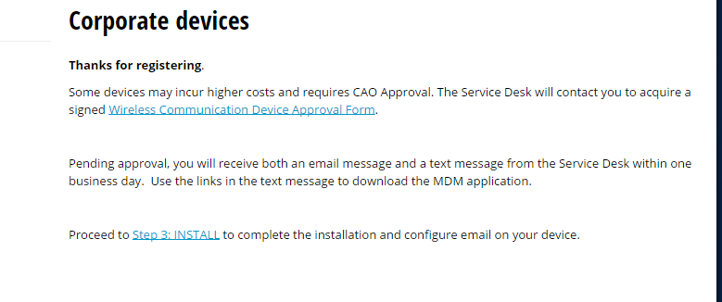

Click on Instructions for the appropriate Phones link
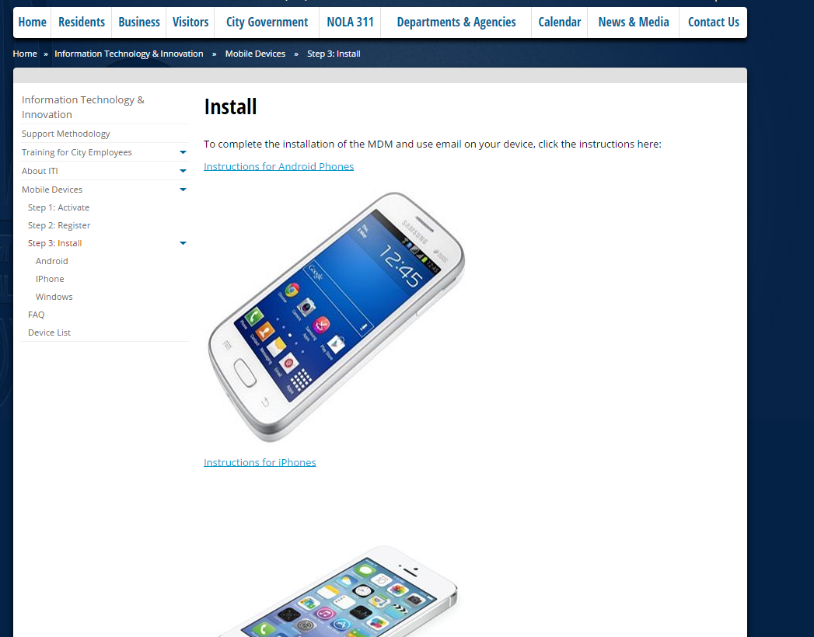

Review the Readiness Checklist to ensure everything is in place for install

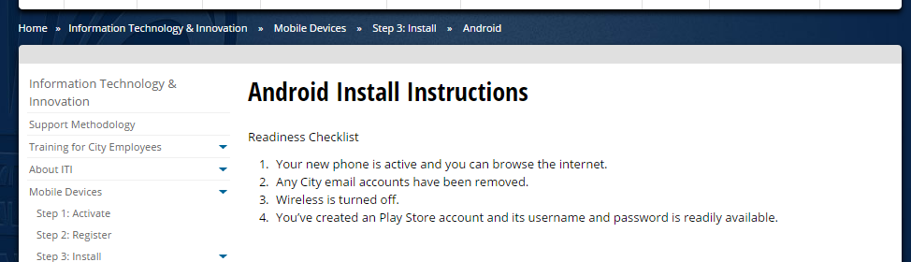
Follow the instructions (steps 1-26) on the rest of the page
